Data Encryption Standard (DES)
The Data Encryption Standard (DES) is a classic symmetric-key block cipher introduced in 1977 and widely adopted by government and industry. DES operates on 64-bit data blocks using a 64-bit key (of which only 56 bits are actually used for security; the other 8 bits are parity bits). It was the first public encryption algorithm approved by the U.S. government (FIPS-46) and became a standard for encrypting commercial and financial data. Because of its simplicity and performance, DES saw extensive use in banking systems, smart cards (e.g. SIM cards), modems, routers and embedded devices. (However, as we discuss below, its short key length makes it insecure by modern standards.)
DES is a block cipher: it encrypts fixed-size blocks (64 bits) of plaintext into 64-bit ciphertext blocks. It uses a Feistel network structure with 16 rounds of processing. In each round, the 64-bit data block is split into a left half (L, 32 bits) and a right half (R, 32 bits). The round function (often called the “mangler” or Feistel function) takes the right half and a round-specific subkey and produces a 32-bit output, which is then XORed with the left half. After that, the halves are swapped: the previous right half becomes the new left half, and the XOR result becomes the new right half. In ksummary, each round does:
- Li=Ri−1and
- Ri=Li−1⊕F(Ri−1,Ki)
where Ki is the 48-bit subkey for round i. The use of this Feistel structure means that encryption and decryption use the same basic operations – decryption simply applies the subkeys in reverse order.
Key characteristics of DES include:
- Block size: 64 bits (plaintext→ciphertext). Every 64-bit block is processed independently (though in practice one uses chaining modes).
- Key length: 64 bits input; 8 bits are used for parity checks and ignored for security, yielding an effective 56-bit key. From this key, 16 different 48-bit round keys are derived.
- Rounds: DES performs 16 rounds of the Feistel function. Each round uses a different 48-bit subkey. The same algorithm is used for all rounds (Feistel structure) but with different subkeys.
- Subkeys: Each round key is 48 bits, obtained from the 56-bit key by fixed permutations and bit shifts (the DES key schedule). In each round the 56-bit key is split into two 28-bit halves, left-shifted (one or two bits depending on the round), and a Permuted Choice 2 (PC-2) selects 48 bits from the 56 to form the subkey.
- Symmetric: The same secret key is used for both encryption and decryption.
DES Round Function (Feistel Function) and S-Boxes
Each of the 16 rounds applies the Feistel (mangler) function F(R,K) to the right half (32 bits) and the round key. The steps in one round of DES are:
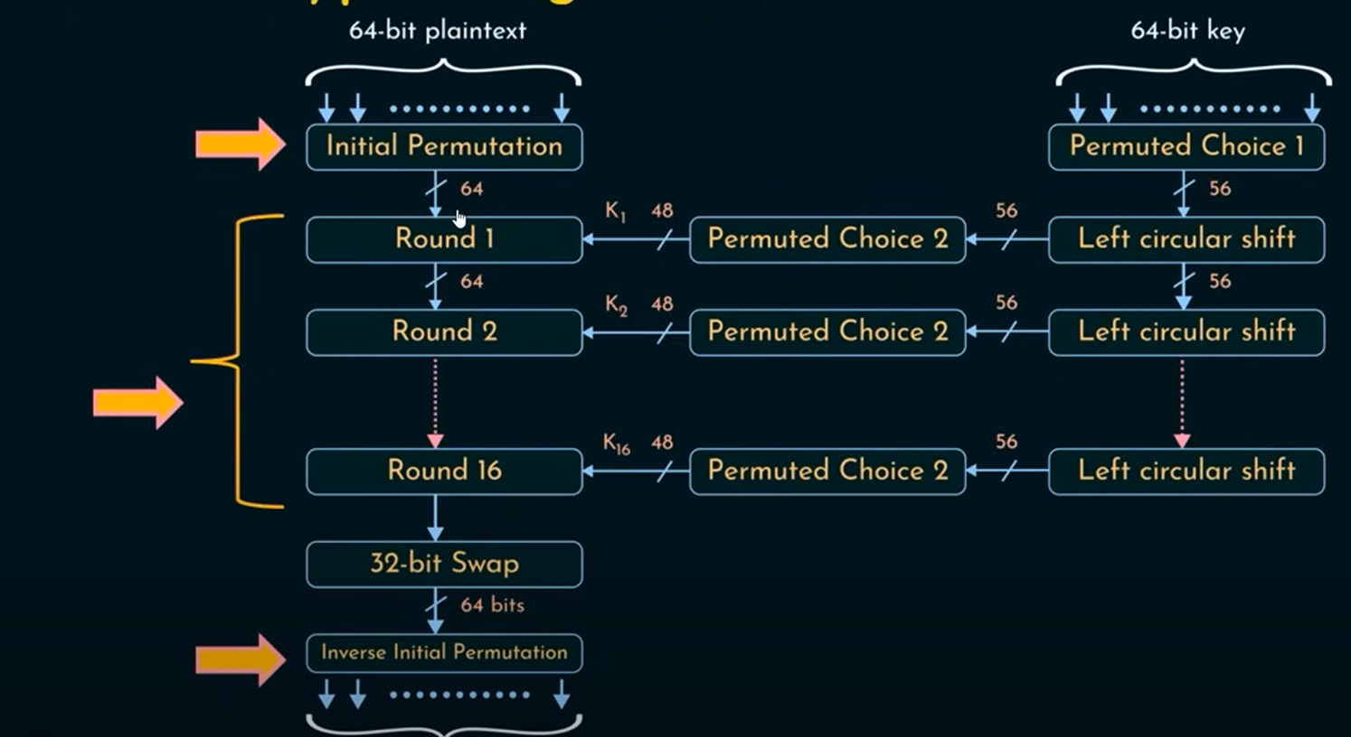

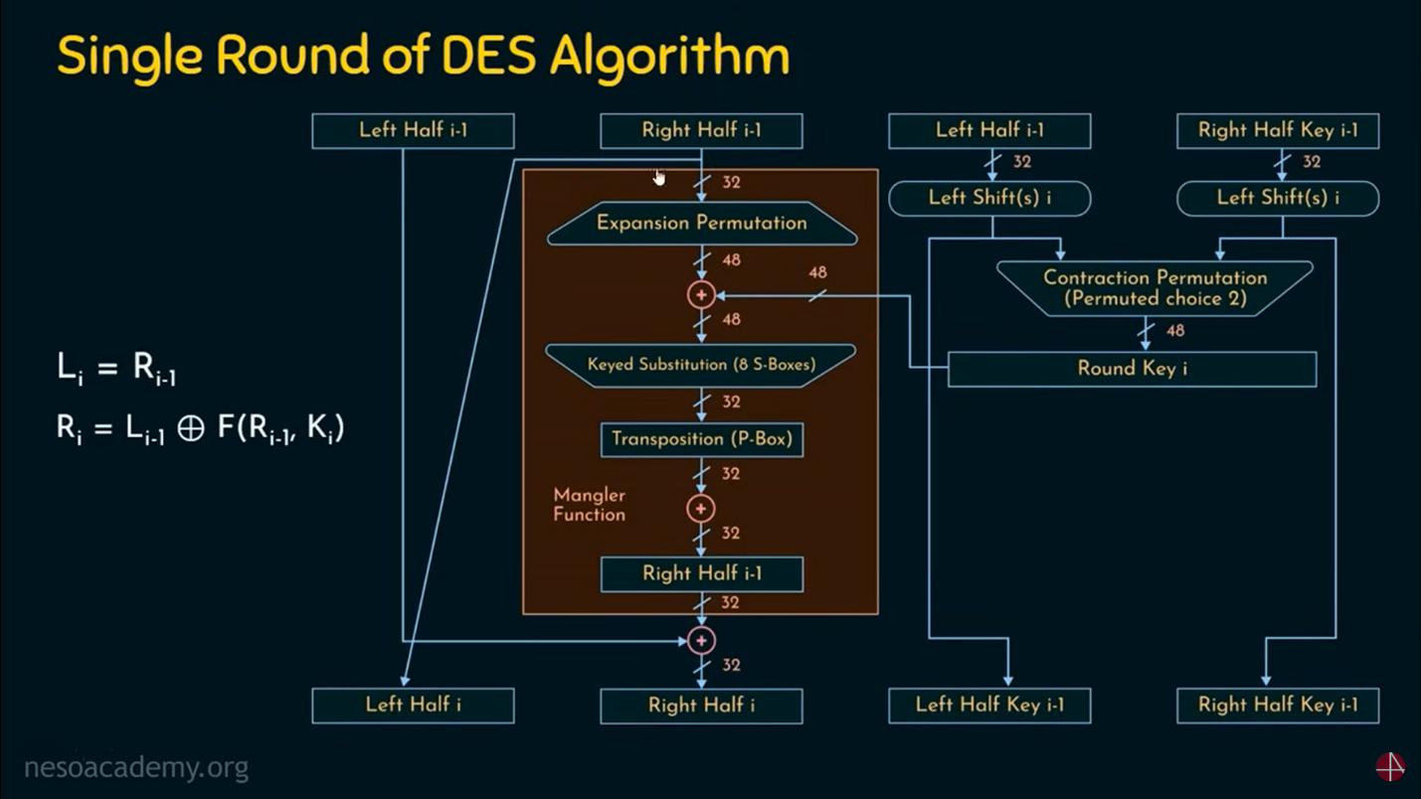

ZZ
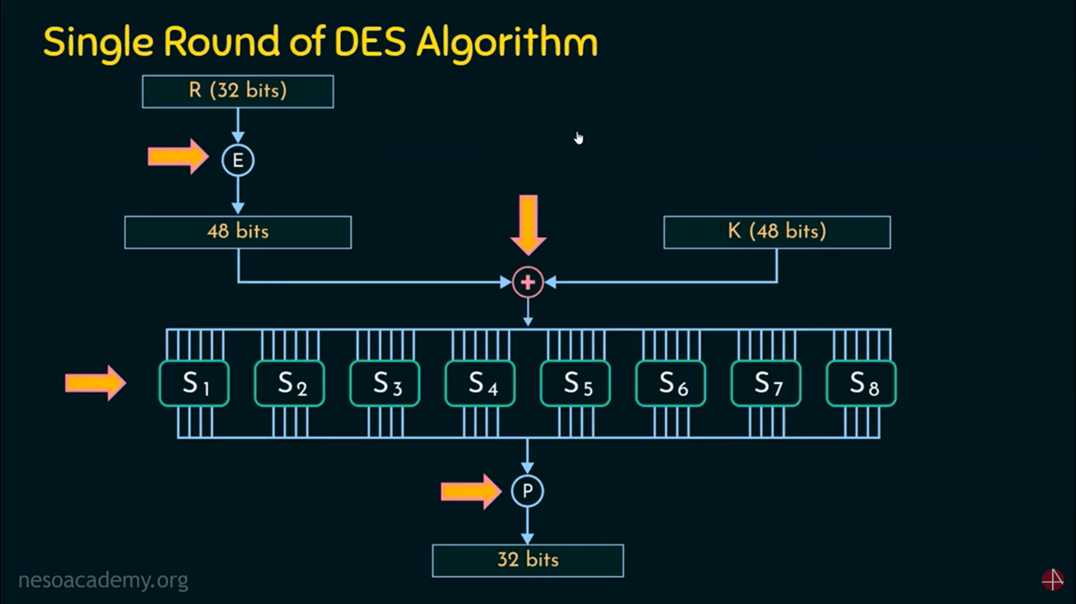

- Expansion (E): Expand the 32-bit right half to 48 bits by duplicating certain bits according to a fixed expansion table. This ensures some bits are reused, providing diffusion.
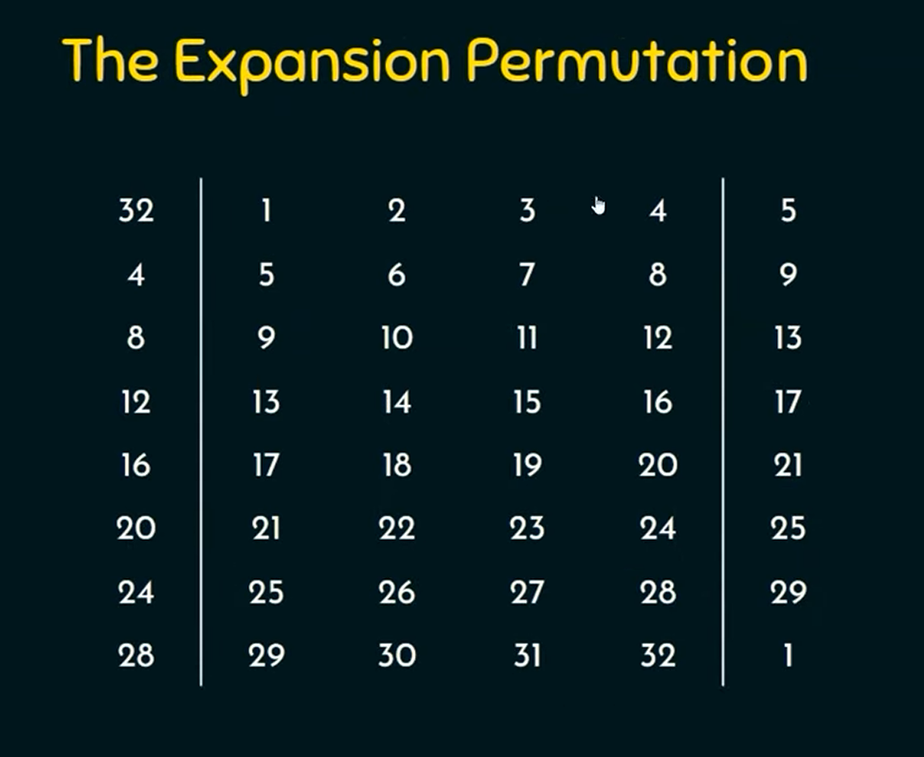

- Key Mixing: XOR the expanded 48-bit R with the 48-bit round key Ki.
- Substitution (S-Boxes): Divide the 48-bit result into eight 6-bit chunks. Each 6-bit chunk goes into one of eight fixed S-boxes (S1–S8), each of which outputs 4 bits. Each S-box is a nonlinear lookup table that maps a 6-bit input to a 4-bit output. This substitution step is the primary source of nonlinearity (confusion) in DES. For example, a 6-bit input “101010” into the first S-box might output “0110” (the binary for decimal 6). Collectively the eight S-boxes reduce 48 bits to 32 bits.
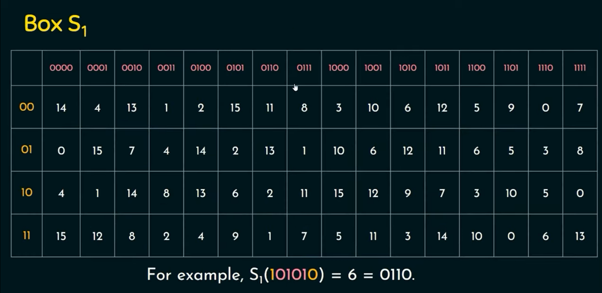

- Permutation (P-Box): Permute (rearrange) the 32 bits output by the S-boxes using a fixed 32×32 permutation table (the P-box). This step spreads (“diffuses”) the bits so that each output bit depends on bits from multiple S-boxes.
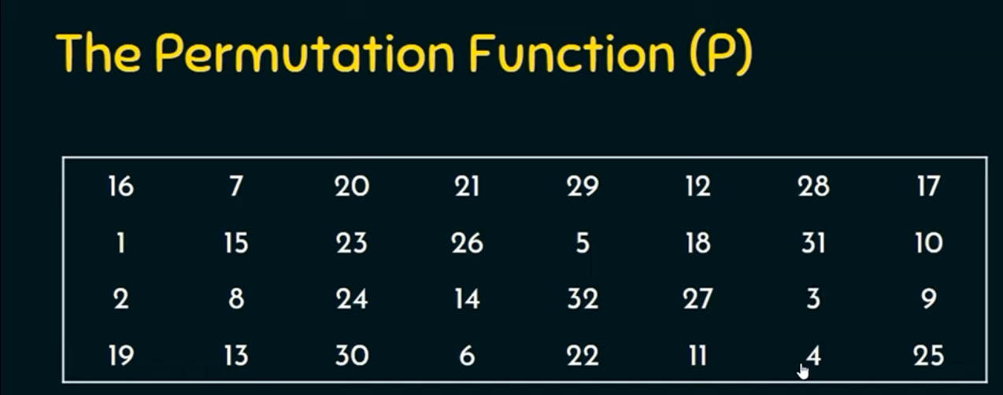

- XOR and Swap: XOR the 32-bit result of the P-box with the 32-bit left half. That XOR result becomes the new right half for the next round, and the old right half becomes the new left half. In formula form: Ri=Li−1⊕F(Ri−1,Ki) and Li=Ri−1
These round operations may be listed as a step-by-step Feistel round:
- Step 1: Apply initial permutation (IP) to the 64-bit input block (a fixed bit-shuffle).

- Step 2: Split into L_0 and R_0 (32 bits each).
- Step 3: For rounds i=1 to 16:
  - Expand Ri−1 from 32 to 48 bits.
  - XOR with round key K_i.
  - Apply the 8 S-box substitutions to get 32 bits.
  - Apply the P-box permutation to those 32 bits.
  - Compute Ri=Li−1⊕(output) and Li=Ri−1.
- Step 4: After 16 rounds, swap the final halves (so that the last XOR output becomes the left half).
- Step 5: Apply the inverse initial permutation (IP⁻¹) to the combined 64 bits to produce the ciphertext.
Figure 1 (below) illustrates one Feistel round in DES:
- Left side shows input halves Li−1, Ri−1. Right side shows output Li, Ri. The right half is fed unchanged (except through the round function), while the left half is transformed by F and then swapped.
Each S-box is a fixed table (not secret); for security, DES relies on the secrecy of the 56-bit key and the multiple rounds. The inverse process (decryption) simply runs the same algorithm with the 16 subkeys applied in reverse order. Because of the Feistel structure, the same circuit (round function) can be used for both encryption and decryption (with reversed key schedule).
Key Schedule
The DES key schedule generates one 48-bit round key for each round from the 56-bit effective key. The steps are:
- Initial Key Permutation (PC-1): The 64-bit original key (with parity bits) is permuted by dropping every 8th bit to yield a 56-bit key. The discarded bits were originally for parity and do not contribute to security.
- Split and Shift: The 56-bit key is split into two 28-bit halves. In each of the 16 rounds, both halves are rotated left by either 1 or 2 bits (the rotation schedule is predetermined: rounds 1,2,9,16 rotate by 1; all others by 2).
- Round Key Permutation (PC-2): After shifting, the two 28-bit halves are combined and permuted by another fixed table (PC-2) that selects 48 of the 56 bits to form the round’s subkey K_i (again, the positions are fixed by the standard).
These subkeys are used in each round’s XOR step. Because of the shifting, each round key differs from the others. Overall, the 64-bit input key (with parity) yields 16 unique 48-bit subkeys.
Security and Weaknesses
DES’s design was very strong for its time, but its 56-bit key length is too short by modern standards. A 56-bit key allows only 2^{56} (~72 quadrillion) possibilities – a search space that high-performance hardware or distributed efforts can exhaust in days or less. In fact, in 1998 the Electronic Frontier Foundation built a machine that cracked a DES key in 56 hours; by 1999 they did it in 22 hours. Today commercial “DES cracking” services can recover a DES key in on the order of a day. Thus, brute-force attack is practical, and DES is no longer considered secure. (As one cybersecurity analysis notes, “its 56-bit key is too short” – a German court even ruled a bank negligent for using DES, calling it “out-of-date and not secure enough.”.)
Besides brute force, DES is also vulnerable to modern cryptanalysis techniques (differential and linear cryptanalysis) which exploit patterns in how S-boxes map inputs to outputs. Those attacks do not fully break DES, but they reduce its effective security.
Because of these issues, DES has been superseded by more secure ciphers. The Triple-DES (3DES) variant was invented to strengthen DES: it applies DES three times with up to three different keys, giving an effective key size of 112 or 168 bits. However, even 3DES is being phased out; NIST deprecated 3DES for new systems after 2017 and disallowed it after 2023. Modern standards call for AES (Advanced Encryption Standard, with 128/192/256-bit keys) or other algorithms, rather than DES/3DES.
Real-World Use and Applications
While DES itself is now obsolete for new systems, it played a crucial historical role. Between the late 1970s and early 2000s, DES was the primary cipher for securing sensitive data in finance and government. Banks used DES or 3DES to encrypt PINs and ATM messages, telecom systems used it in satellite links, and many legacy devices and protocols still supported DES for backward compatibility. For example, early SSL/TLS and SSH protocols offered “DES” as a cipher option (though it is now disabled by default). DES was also used in electronic key cards and hardware modules.
NIST officially retired DES in 2005, replacing it with AES. However, some legacy systems (like older smart cards or industrial controllers) may still use DES. Understanding DES is therefore important for maintaining or upgrading these systems. In academic settings, DES is widely taught as a concrete example of a Feistel cipher and to illustrate concepts like S-box substitution and permutation operations.
Practical Implementation Tips
applying DES in practice reinforces the theory. In modern environments you normally would not write DES from scratch (use AES instead!), but you can use cryptographic libraries to experiment. Many languages and tools still provide DES support. For example, in Python the PyCryptodome library has a DES module. One can do:
from Crypto.Cipher import DES
key = b'8bytekey' # 8-byte (64-bit) key (parity bits will be ignored)
cipher = DES.new(key, DES.MODE_CBC, iv=b'8byteivv')
ciphertext = cipher.encrypt(pad(plaintext,8))
Here an 8-byte key and 8-byte IV (for CBC mode) are used. In fact, the PyCryptodome docs show a simple example using DES and OFB mode. (They also warn “Use AES instead” for real applications.) Similarly, command-line tools like OpenSSL support DES: e.g. openssl enc -des -in plain.txt -out cipher.des -K <hexkey>. In Java/C#, one can use built-in crypto libraries (Cipher.getInstance("DES/CBC/PKCS5Padding"), etc.) by supplying a 56-bit key and 64-bit IV.
As a practical exercise, you can encrypt and decrypt sample data. For example, write a short program that:
- Reads a 64-bit block (e.g. 8 ASCII characters),
- Applies the DES initial permutation,
- Executes 16 Feistel rounds (you may reuse a library’s round function or write your own), and
- Applies the final permutation.
Compare the result to a known good implementation (or use a test vector). Also try decrypting a ciphertext by reversing the subkey order – it should yield the original plaintext. Many libraries also allow testing different modes (ECB vs CBC) and highlight why ECB is insecure (it does not hide patterns).
For practical labs, emphasize padding and modes: because DES is a block cipher, real messages longer than 64 bits must be split and padded (e.g. PKCS#5 padding). Also note that ECB mode (encrypting each block independently) is vulnerable to pattern leakage, while CBC mode with a random IV is safer.
Summary
- DES is a 16-round Feistel block cipher operating on 64-bit blocks with a 56-bit key.
- It combines fixed initial/final bit-permutations, expansion/permutation operations, and eight nonlinear S-boxes (6-bit→4-bit substitutions) in each round.
- The same algorithm (and same key) is used for encryption and decryption, differing only in key order.
- Because of its short key, DES is no longer secure against brute-force and is replaced by AES in most applications.
- Historically, DES was widely used (e.g. in government and banking) and is an important teaching example for symmetric ciphers.
Students should understand both the theoretical structure of DES (rounds, S-boxes, Feistel swaps, key schedule) and be able to apply it in practice using standard cryptographic libraries. Implementing a simple DES encrypt/decrypt helps illustrate concepts like block structure, permutations, substitution, and the impact of key size on security.

What is a Parity Bit?
A parity bit is a simple error-detecting mechanism. It's a single bit added to a group of bits to ensure the total number of 1s is either even (even parity) or odd (odd parity). In DES, each byte (8 bits) of the key must have odd parity.
That means:
- Each 8-bit block (byte) in the key should have an odd number of 1s.
- The 8th bit in each byte is adjusted so that the whole byte has odd parity.

Example:
Let’s take one 8-bit byte from the key:
- Suppose the first 7 bits are: 1010101 → it has 4 ones (even).
- To make it odd parity, the 8th bit (parity bit) must be 1.
- Final byte: 10101011 → now it has 5 ones (odd parity ).
If instead the first 7 bits were 1111110 (six 1s), the parity bit would also be 1 to make the total 7 ones.

Why is this used in DES?
- To ensure key integrity when transmitting/storing keys.
- It does not increase security — it’s just a basic error-checking tool.
- Effective key length remains 56 bits, because the parity bits are ignored during encryption.

Feature | Value
Total Key Size | 64 bits
Used for Encryption | 56 bits
Parity Bits | 8 bits (1 per byte)
Purpose | Error detection (not security)
Parity Type | Odd parity (each byte)

Perfect — here's how you can structure tasks for your undergraduate cryptography students around DES, including encryption, decryption, and basic cryptanalysis.

Cryptanalysis
Task 4: Known-Plaintext Attack (Mini Brute Force)
Setup:
- Provide students with:
  - A short ciphertext (8 bytes long)
  - A known plaintext that was encrypted (e.g., “Marwan!!”)
- Tell them the key is one of a few (e.g., "key00000", "key00001", ..., "key00010")
Goal:Deliverable: Identify the correct key and explain how the known-plaintext made it possible.

Task 5: Ciphertext-Only Frequency Analysis
- Give students a long ciphertext encrypted using DES in ECB.
- Ask them to:
  - Count repeating blocks (each 8 bytes).
  - Try to infer plaintext structure (e.g., repeated words).
Deliverable: Count repeated blocks and hypothesize about the plaintext.

Task 6: DES Key Recovery (Brute Force in Limited Space)
Setup:
- You generate a DES ciphertext using a key like b'brute001'.
- Students are told the key starts with brute00 and last character is a digit from 0 to 9.
Goal:
- Write a brute-force script to try all 10 possible keys.
Deliverable: Python code + recovered plaintext.

Bonus Challenge
Custom DES Round Simulation
- Simulate a single DES round manually in Python:
  - Expand R using E-table
  - XOR with subkey
  - Apply 1 or 2 S-boxes
  - Apply simple permutation
- Print intermediate values at each step.
This reinforces internal DES mechanics.
Deliverable: Output of round inputs, S-box result, permutation result.

Table
Task | Focus Area | Outcome
1 | ECB Encryption/Decryption | Understand DES basics
2 | ECB Patterns | Show ECB weaknesses
3 | CBC Mode | Compare secure block modes
4 | Known-Plaintext Attack | Brute-force by logic
5 | Ciphertext-Only | Analyze ciphertext patterns
6 | Key Brute Force | Crack short keyspaces
7 | DES Round Simulation | Internal operations mastery

THE SECRET

